CACV Member Highlight: Honoring Cancer Survivor Month with Michelle Futrell
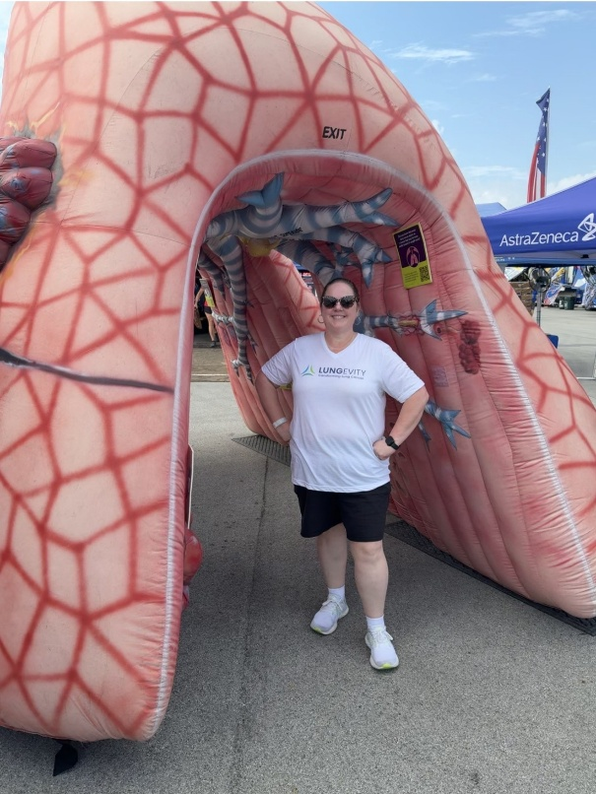
In recognition of Cancer Survivor Month, we are honored to spotlight Michelle Futrell, Director of Lung Cancer Screening Programs and Initiatives at LUNGevity and a member of the CACV Board of Directors. Michelle’s story is one of faith, resilience, and advocacy, both for herself and for others navigating the life-changing experience of a cancer diagnosis. Her experience as a survivor also informs her leadership within CACV, where she works to lessen the impact of cancer across Virginia.
As a cancer survivor, Michelle says one of the most important lessons she learned was to advocate for herself and hold on to hope. Even with her background as a nurse, she experienced how difficult it can be to navigate appointments, delays, and uncertainty. Those challenges strengthened her commitment to helping others, especially people who may not know what questions to ask or where to turn for support.
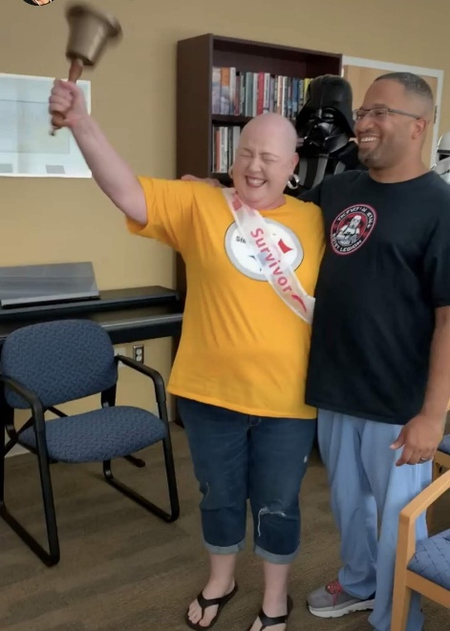
Michelle credits much of her strength during treatment and survivorship to the people who gave her hope. She speaks powerfully about life after cancer, a phase that is often misunderstood. While treatment may end, survivorship brings its own emotional and practical challenges. Her message to health care providers and the public is simple: do not lose your empathy. For the person hearing the diagnosis, life is forever divided into “before cancer” and “after cancer.”
Michelle has been involved with CACV for nearly a decade. She was drawn to CACV because it offered a place to learn, collaborate, and ensure that lung cancer screening had a stronger voice in statewide conversations. Over time, that involvement has become an important avenue for her broader advocacy; not only for lung cancer screening, but also for breast cancer survivorship, and early detection of all cancers.
Today, Michelle brings that same survivor perspective to her work at LUNGevity, where she is excited about expanding awareness through a broader lung health platform called “Know your Lungs” and changing the narrative around lung cancer screening. She also sees powerful opportunities for collaboration across cancer organizations to promote multiple screenings together and help more people access early detection.
This Cancer Survivor Month, Michelle’s story reminds us that survivorship is not only about enduring, but also about using your voice to bring hope, improve care, and advocate for a healthier future. Through CACV, she sees opportunities to build stronger partnerships, reach new audiences, and help more Virginians understand the value of screening and early detection.

