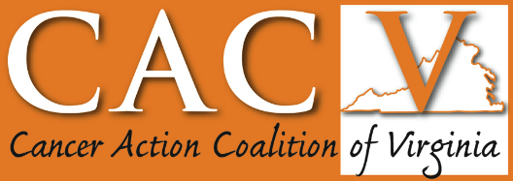
Quarterly Meeting
Thursday, June 11, 2026

Agenda
Theme - Addressing Food Insecurity Across the Commonwealth in Cancer Care and Prevention
Register: https://us02web.zoom.us/meeting/register/WH0OXuwVRWuXVRXBWjonwQ

9:30 – 9:45 am
Welcome and Survivor Testimonial, Melissa Earley

9:45 – 10:15 am
Keynote Speaker: Food Security Landscape in VA Myths and Facts & an Introduction to Food Pharmacies and their Impact
Hollie Lutz, Director of Development and Communications, Federation of VA Food Banks

10:15 – 10:45 am
Food security among cancer survivors and caregivers: Their experience and strategies for improving their food access
Kathleen Porter, PhD, RD from UVA and Victor Olayemi from VT

10:45 – 10:55 am
BREAK

10:55 – 11:35 am
Innovative Solutions from Around the State: popcorn presentations followed by a 10-minute panel discussion.
- Underground Kitchen, Richmond
- Healthy Harvest, Northern Neck
- ODU/EVMS, Hampton Roads
Moderator: Riguey King

11:35 – 11:45 am
CACV Business, Annie Turner

11:45 – 12:00 pm
Members Need to Know - Cancer Cluster, Dr. DeSilva, Virginia Department of Health
- Overview of clusters in the state

